1. Debugging in VS code

* Google recently released a tool which we can use to debug which is called NDB
* NDB stand for Node Debugger, is actually just an NPM package
* Install NDB ex. npm I ndb
  + Install globally ex. Sudo npm i ndb –global
  + Install locally ex. npm i ndm –save-dev

1. To use this go to **package.json** and add a new script, on script section

Ex.

"scripts": {

"start": "nodemon server.js",

"start:prod": "NODE_ENV=production nodemon server.js",

"debug":"ndb server.js" //ndb is debugger and server.js is an entry point

// this is gonna work no mater if you installed globally or locally

},

* To run the debugger simpy run the

Ex. npm run debug

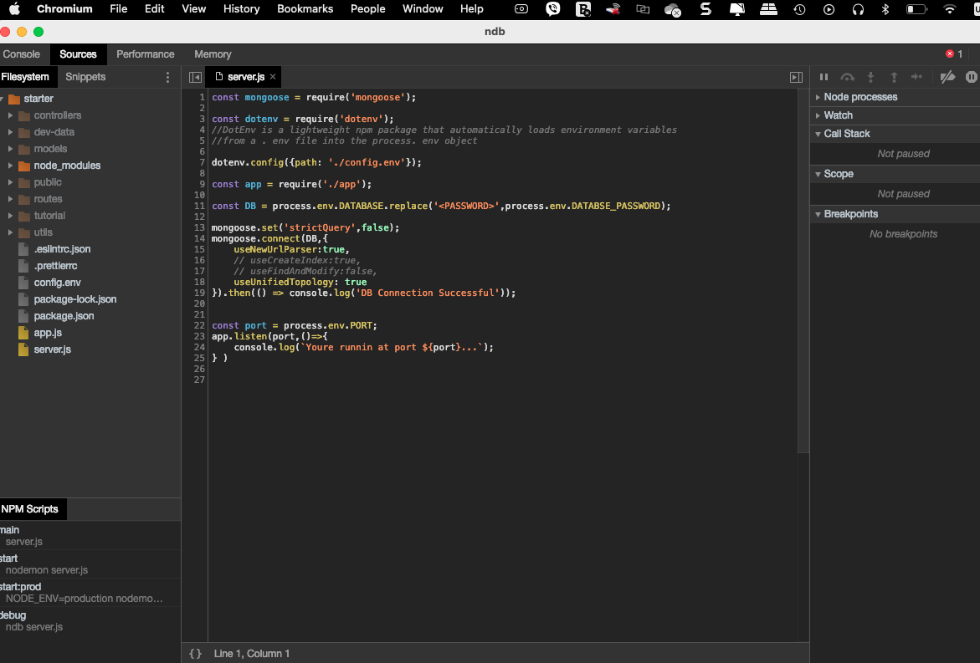

* This can make a breakpoint

Lecture

**ERROR HANDLERS**

2 types of errors:

1. Operational errors

Problems that we can predict will happen at some point, so we just need to handle them in advance

* + Invalid path accessed;
  + Invalid user Input (validator error from mongoose)
  + Failed to connect to server
  + Failed to connect database
  + Request timeout
  + Etc.

1. Programming errors

Bugs that we developers introduce into our code. Difficult to find and handle

* + Reading properties on undefined
  + Passing a number where an object is expected
  + Using await without async
  + Using req.query instead of req.body